NBA Stats Project

NLP
Lemmatization - don't need as not real words
Deletion of letter
Switching Letter
Replace Letter
Insert new Letter

For word editing – see Regex
https://pypi.org/project/regex/

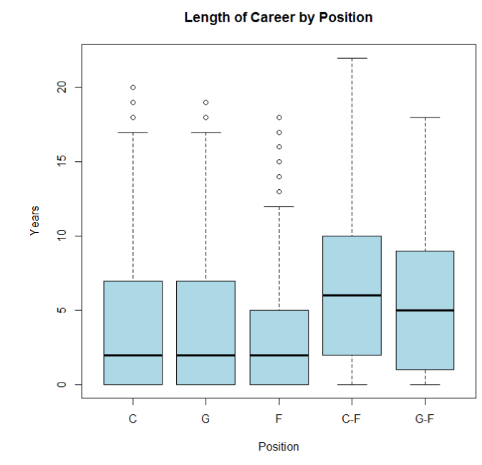
Data Selection
Considerations:
Having available data – play-by-play era is a good cutoff (See Figure History of NBA Data)
Chose to go from 1996 to current – has enough similarities to modern era and similar injury/health technology.
Chose to have upper limit of training data be active players drafted before 2016.


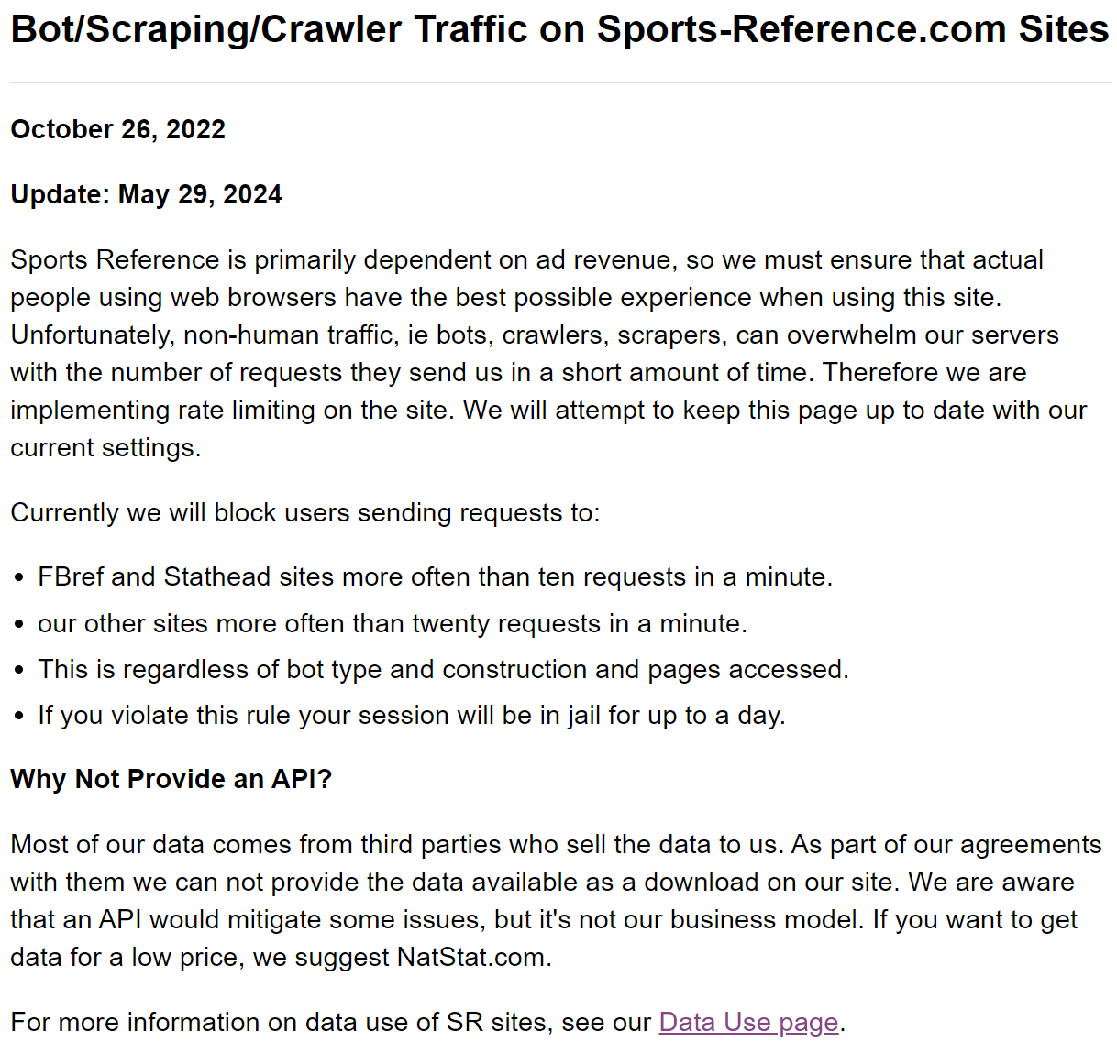
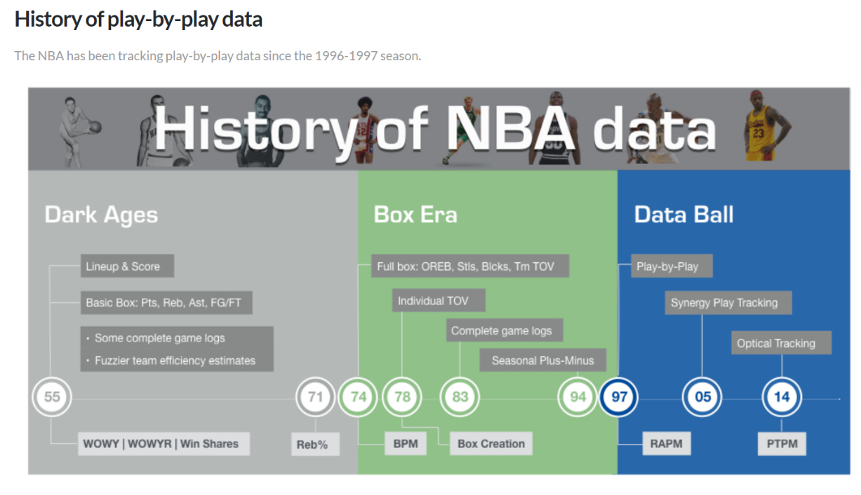
Using BasketballReference but there are limitations (see Figure Bot/Scraping/Crawler Traffic)

ML Methods

- Create paths for each players career path (matrix for each player)
- Split into training and test with splits done according to career length and gamescores
- Clustering the career paths to identify archetypes/classes – HDBSCAN
- Classification of each new player comparison to identify best fit
- Do regression/prediction of players career’s using the class model – superpose each model on one another using weights
- Refine using both comparison of actual paths and qualitative data e.g. injuries etc
- HDBSCAN for clustering https://hdbscan.readthedocs.io/en/latest/how_hdbscan_works.html https://link.springer.com/content/pdf/10.1007/978-3-642-37456-2_14.pdf
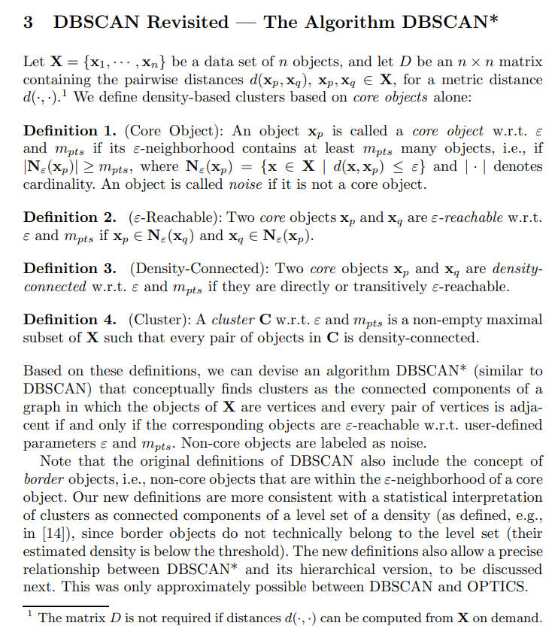

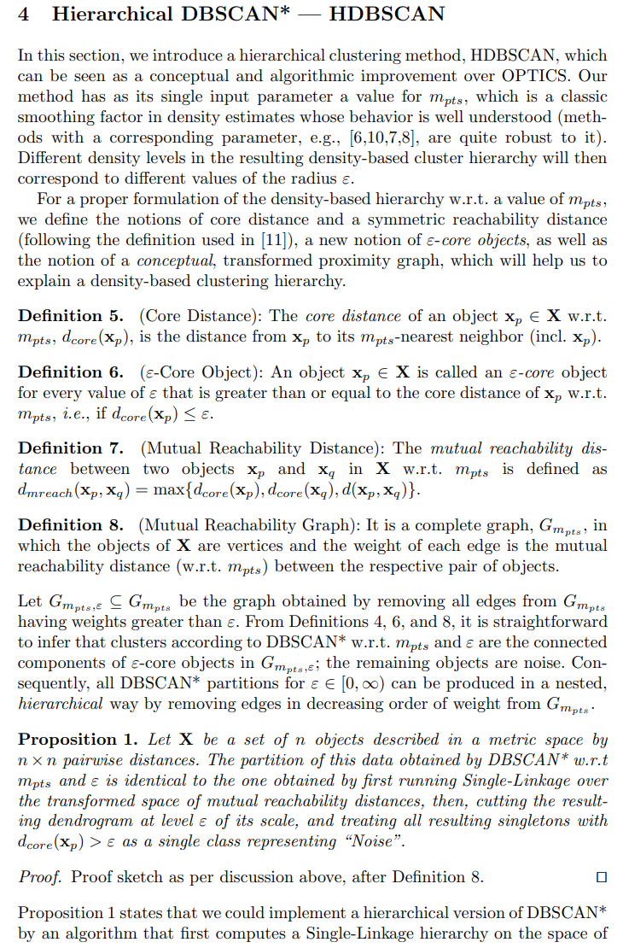
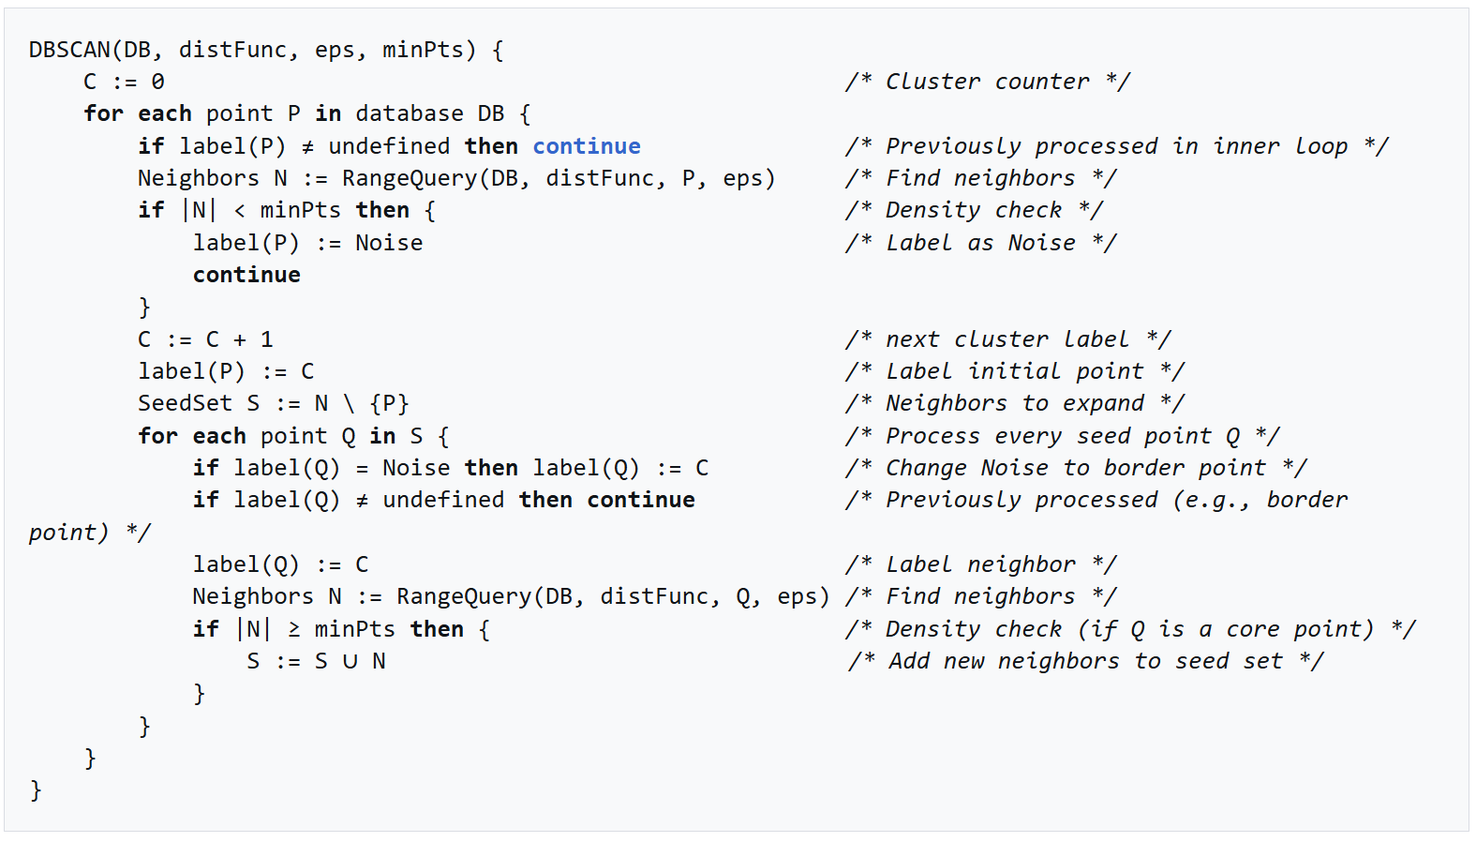
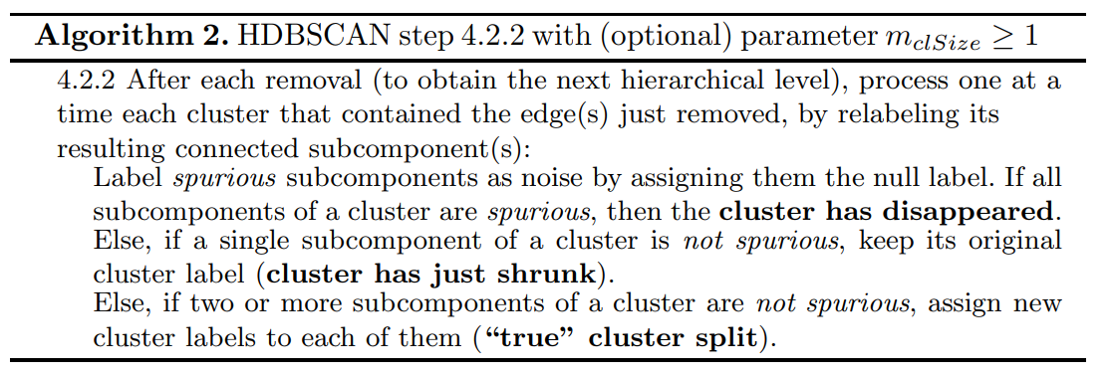
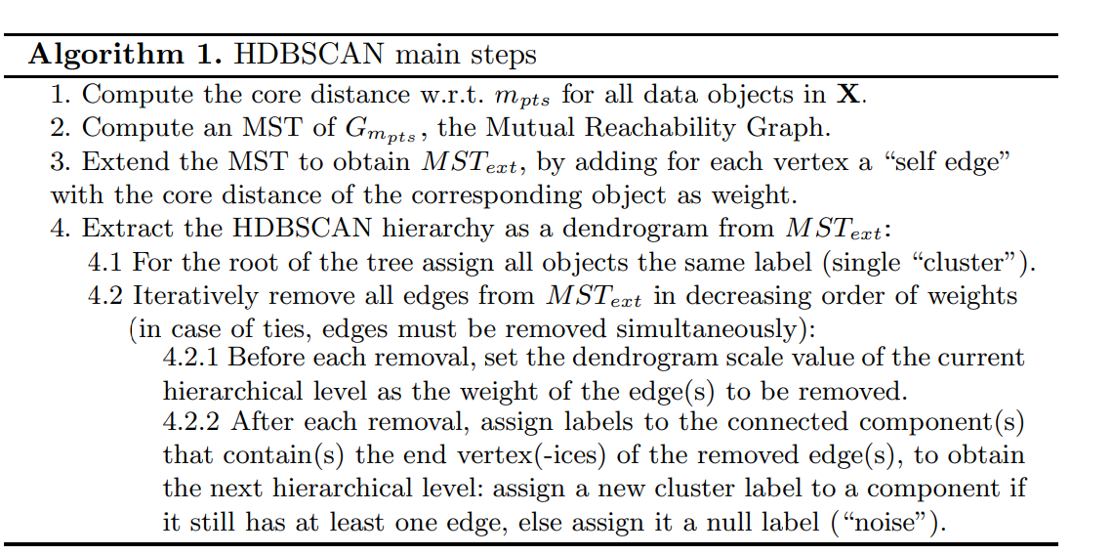
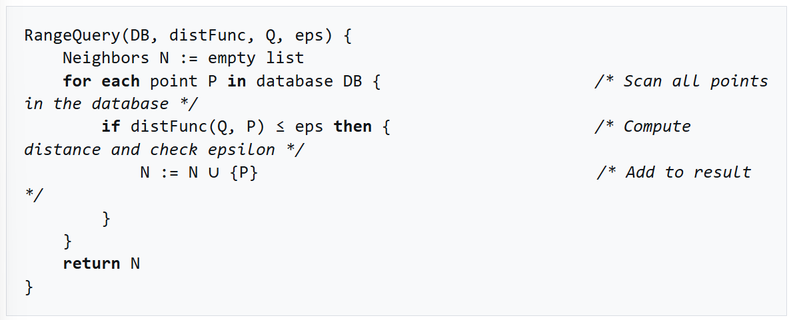
m_{pts} = minimum points required to form a dense region (~low 100s/high 10s)
ε = neighborhood? Sets the max distance from the point which is considered its neighbourhood
- Compute the core distance with respect to m_{pts} (number of objects? Smoothing factor? Parameter?) for all data objects in X The core distance of an object x_{p} ∈ X w.r.t. m_{pts}, d_{core}(x_{p}), is the distance from x_{p} to its m_{pts}-nearest neighbour
${c_{m}}_{pts }(x_{p}) = d\left(x_{p}, m_{pts} -NN\left(x_{p}\right)\right)$
d(.) = Euclidean distance/distance function

- Compute an Minimum Spanning Tree of $G_{m_{pts}}$ (Mutual Reachability Graph)
- Extend the MST to obtain MST_{ext} by adding for each vertex a “self edge” with the core distance of the corresponding object as weight
- Extract the HDBSCAN hierarchy as a dendrogram from MST_{ext}
  - For the root of the tree, assign all objectsthe same label (single “cluster”)
  - Iteratively remove all edges from MST_{ext} in decreasing order of weights (in case of ties, edges must be removed simultaneously):
    - Before each removal, set the dendogram scale value of the current hierarchical level as the weight of the edge(s) to be removed
    - After each removal, assign labels to the connected component(s) that contain(s) the end vertex(-ices) of the removed edge(s), to obtain the next hierarchical level: assign a new cluster label to a component if it still has at least one edge, else assign it a null label (‘noise’)
Scored for Evaluation
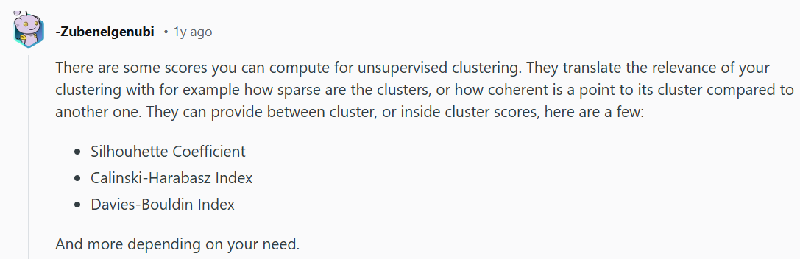
- Silhouhette Coefficient
- Calinski-Harabasz Index
- Davies-Bouldin Index

Estimated Operations Requires
5289 players, 13989405 player comparisons, 13989405 · (years of career)

